Personality and Political Affiliation In Germany And The USA
Moritz M. Konarski
American University of Central Asia

Contact: konarski_m@auca.kg
Abstract
Do Germans identify with political parties the same way US-Americans do? This research paper compares the relationship between personality traits and political affiliation in Germany and the USA. The comparison is based on the studies by Gerber et al. (2012) for the USA and Bakker et al. (2015) for Germany. These studies examined the relationship between personality and political affiliation in the respective countries. To measure personality they used the Five-Factor model of personality.
This study finds that the influence of the personality factors on the direction of a person's political affiliation is the same in Germany and in the USA. Furthermore, in both countries the strength of the factors is similar. The implications of this research as well as future research options are discussed.
Keywords: five-factor-model, personality traits, political science

Personality and Political Affiliation In Germany And The USA
Why do people vote for certain parties? This question is important for democracies because the political affiliation of voters decides which politician or party receives governmental authority. Some of the most powerful countries worldwide, like Germany and the USA, are democracies. Their elections have effects that far outreach their own borders, making them very relevant in global politics.
Recently, the USA and Germany experienced a political swing to the right. This manifested itself in the election of Donald Trump as president of the USA and the election of the right-wing Alternative for Germany (AfD) into German parliament. This swing was caused in a large part by the adverse effects of globalization, migration, and terrorism. Even though each nation’s experiences were different, the same swing to the right occurred.
One cause for the similar swing to the right could be the identical relation between personality traits and political affiliation in Germany and in the USA. This fundamental relationship could mask the differing effects of the mentioned problems and cause the same political change. Based on this, it can be assumed that the same relationship between personality and political association exists in both nations. It is supported by the fact that both countries are representative democracies, have distinct left-wing and right-wing parties and share core values and traditions.
Consequently, the aim of this paper is to examine whether personality traits influence the direction of political affiliation the same way in Germany and in the USA. Does each trait influence political identification by the same amount? Based on the aforementioned similarities between the nations, it can be supposed that the influence of each trait on the direction of political affiliation is the same. The relative influence of each trait ought to be similar as well.
The studies by Gerber, Huber, Doherty, and Dowling (2012) as well as Bakker, Hopmann, and Persson (2015) who analyzed personality and political affiliation in the USA and in Germany, respectively, are used to explore this assumption. To measure personality traits, both studies used the Five-Factor model (alternatively called the Big Five traits). The Big Five traits are openness, conscientiousness, extraversion, agreeableness, and neuroticism, which together accurately and reliably describe human personalities (Digman, 1990). A person's political association can thus be reliably linked to their personality traits.
Material and Methods
In their study, Gerber et al. (2012) use data from the 2007-2008 Cooperative Campaign Analysis Project survey. In this internet survey, 12,407 participants of voting age were presented with the Ten-Item Personality Inventory, a questionnaire measuring the Big Five traits, as well as a range of questions on their ideology and demographics. The authors weighed the results to generate a sample representative of the U.S. population. They then calculated the relationship between each of the five traits and a person's political affiliation, either Democratic or Republican.
The study by Bakker et al. (2015) uses data provided by the German Socio-Economic Panel (GSOEP) from two studies in 2005 and 2009. The GSOEP has been surveying households in Germany since 1984 and the authors use the data of 18,157 individuals who participated in both the 2005 and 2009 studies. In both, party identification (between five parties) and strength of identification were assessed and in 2005 the Big Five Inventory-Short Version was used to measure personality traits. They use the collected data to calculate the relationship between personality traits and affiliation for each party in 2005 and 2009.
In this paper’s comparison, the data from Gerber et al. (2012) from 2007-2008 and the data from Bakker et al. (2015) from 2009 will be used because of the proximity of time. It has to be noted that Gerber et al. (2012) use the personality trait emotional stability, while Bakker et al. (2015) use the inverse, neuroticism. In this comparison the data for emotional stability was converted to neuroticism by taking the negative number of Gerber et al.’s result, making it comparable to the study by Bakker et al. (2015).
The relationships which the studies identified cannot be directly compared because they used different statistical models and variables to calculate their results. To compare the studies, the findings of both have to be adjusted. Gerber et al. (2012) represent their results as one number per personality trait, with negative numbers representing Republican (right-wing) affiliation and positive numbers representing Democratic (left-wing) affiliation. To compare the numbers to Bakker et al. (2015), they were adjusted so that the smallest (negative) result has a value of minus one, and the largest (positive) result has a value of plus one. Then, to make figures more intuitive, the algebraic sign was switched so that the left-wing traits are left in a diagram and the right-wing traits are right.
The data of Bakker et al. (2015) from 2009 was first grouped by left-wing and right-wing parties based on the author’s categorization of the parties, to mimic the US’s two-party system. The Greens, the Social Democrats (SPD) and The Left are left-wing, while the Christian Democratic Union and the FDP are right-wing parties. The average of their scores produces numbers that correspond to the two parties in the US (left=democratic, right=republican). The difference between the left-wing and right-wing averages produces data that is comparable to the original data calculated by Gerber et al. (2012). Then the data was adjusted in the same way as Gerber et al.’s data to make it comparable. Both studies’ numbers can now be compared because the largest values of both are equal to plus one and the smallest are equal to minus one. This shows the relative magnitudes and differences between the traits and countries. It is necessary for this comparison.
Results
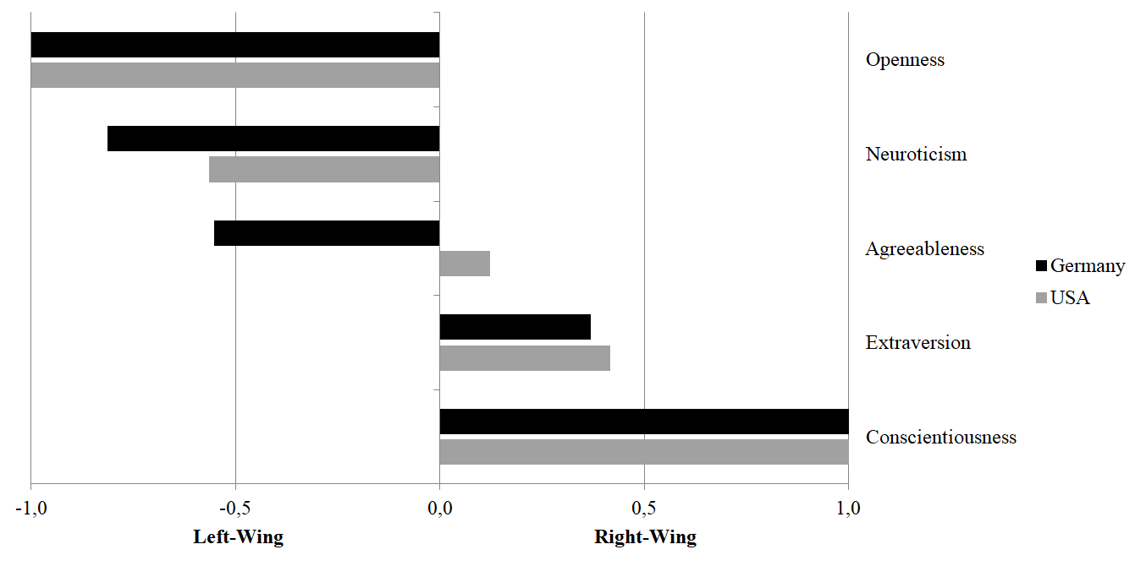
In Figure 1 the adjusted data based on the studies by Gerber at al. (2012) and Bakker et al. (2015) is visualized. The bar chart depicts the influence (x-axis) of each personality trait (y-axis) on the political affiliation of a person in Germany and the USA.
Figure 1. Personality’s influence on political affiliation in Germany and the USA
Figure 1 shows that openness, neuroticism, and agreeableness are associated with left-wing politics, while extraversion and conscientiousness are associated with right-wing politics. Furthermore, Figure 1 shows nearly identical levels of influence in Germany and in the US with all traits except for agreeableness.
Based on the analysis presented in Figure 1, all traits influence the direction of political orientation the same way in Germany as well as the US. Openness and neuroticism are associated with the left while conscientiousness and extraversion are associated with the right in both countries. The only exception is agreeableness which is only associated with the left in Germany. Concerning this, Gerber et al. (2012) note that their findings (for the US) are “statistically indistinguishable from zero at conventional levels” (Gerber et al., 2012, p.666).
The amount of influence each trait has is similar in Germany and the USA. Conscientiousness (right-wing) and openness (left-wing) exert the greatest relative influence on political affiliation in both countries, making them the most significant traits. The second strongest trait is neuroticism which is associated with the left and it is a bit more influential in Germany than in the US. Neuroticism is followed by the right-wing trait extraversion, which is slightly stronger in the US, but close to Germany. The values for agreeableness in the US are statistically zero (Gerber et al., 2012, p.666) while they are relatively big in Germany.
The analysis presented in this paper proves, with the exception of agreeableness, that the influence of each trait on the direction of political affiliation is identical in Germany and the US. Furthermore, it demonstrates that the relative influence of each trait is similar in both countries.
Discussion
A summary by Gerber et al. fittingly describes the findings of this research paper despite the fact that they only summarize their own research. They write, that “Openness, Conscientiousness, and Emotional Stability [the inverse of neuroticism] are all strong predictors of these outcomes, whereas Extraversion is a much weaker predictor” (Gerber et al., 2012, p.666).
Because this summary accurately describes the results of this research paper, is implies a very similar relationship of personality traits and political affiliation in Germany and the USA. As this research provides evidence to the assumption that the fundamental relationship between personality traits and political affiliation is the same in Germany and the USA, this relationship can be partly made responsible for the political swing to the right both countries experienced. This connection may lead to similar political developments for both nations in the future.
Outlook
Future research should explore why the scores for agreeableness were different in Germany and the USA. This is the only trait that significantly differs between the two countries and finding the cause of this diversion would improve this analysis. Furthermore, research should be done that statistically compares the influence of the personality traits in the USA and Germany. Using directly comparable surveys and statistical models would enable a numerical comparison which could focus on the differences between both nations.
In a more differentiated analysis the relationship between the two US-American parties and all five (or six) German parties could be analyzed separately and then compared. This would provide a more accurate representation of the differences between the two political systems, because grouping the German parties by ideology creates a certain error in the comparison. For example, The Left, the Greens and the Social Democrats (SPD) are all left-wing parties, but they are still very different from one another and grouping them together neglects many of the nuances that distinguish them.

References
Bakker, B. N., Hopmann, D. N., & Persson, M. (2015). Personality traits and party identification over time. European Journal Of Political Research, 54(2), 197-215. doi:10.1111/1475-6765.12070
Digman, J. (1990). Personality structure: Emergence of the five-factor model. Annual Review Of Psychology, 41(1), 417-440.
Gerber, A., Huber, G., Doherty, D., & Dowling, C. (2012). Personality and the strength and direction of partisan identification. Political Behavior, 34(4), 653-688. doi:10.1007/s11109-011-9178-5

